**Name. Priti yadav**

**Rollno.106**

**Class .FYIT**

**PRACTICAL NO : 2 }**

**INDEX….**

**1) CREATING ACCOUNT IN GITHUB**

**2) CREATING A REPOSITORY**

**3) CLONING REPOSITORY**

**AIM : Creating account, repository and cloning repository in github.**

**#1) CREATING ACCOUNT IN GITHUB.**

**[Step 1] : Type GitHub login in any browser and search it and then click on official github link. After that Github login page will appear then click on Create an account Option.**

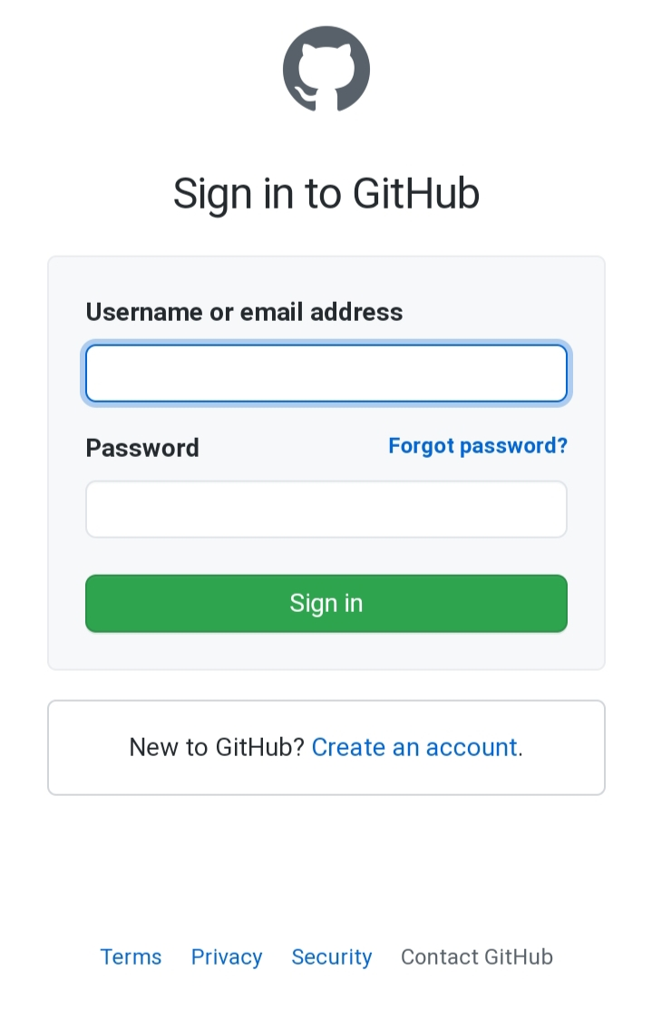

**CLICK HERE TO CREATE NEW ACCOUNT IN GITHUB.**

**Step 2 : Now enter username ,Email id and set password for your account and then click on verify account and solve the captcha ( it will ask three times to solve the given task) and after that click on the create account.**

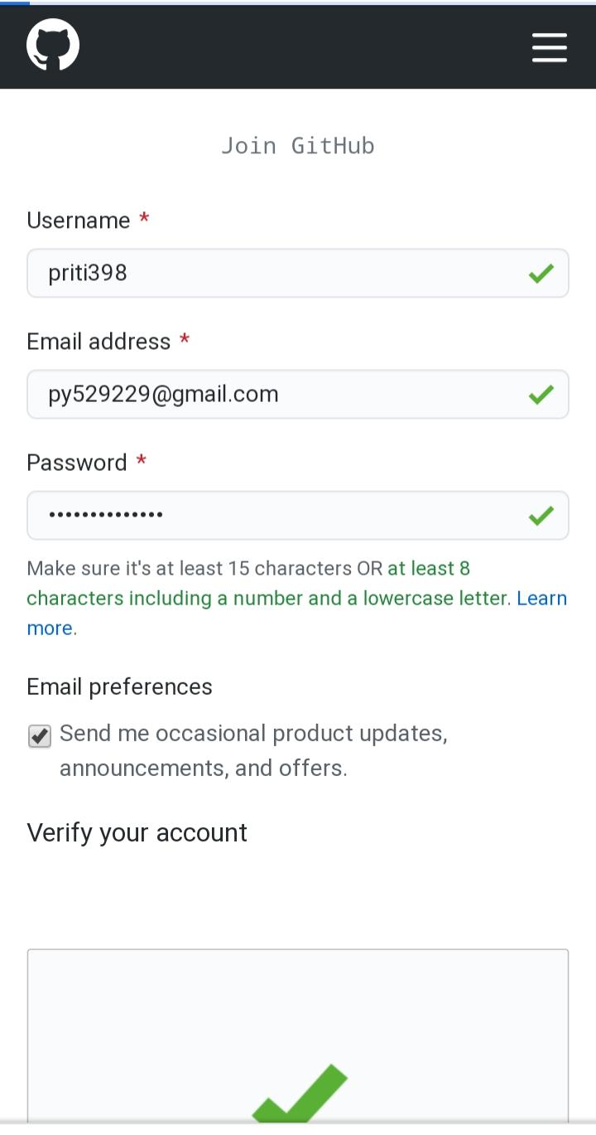

**AFTER ENTERING USERNAME PASSWORD AND COMPLETING CAPTCHA CLICK ON CREATE ACCOUNT.**

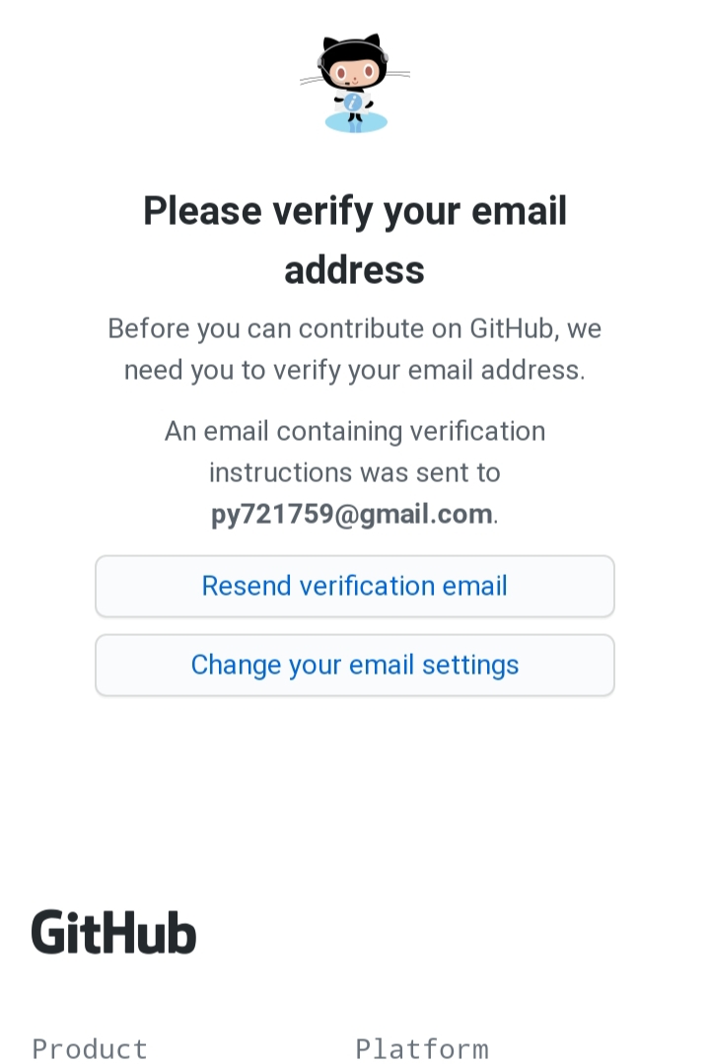**STEP 3 : After clicking on the create account you will receive a mail on your email account which you have entered while the creating account for verification. Now you have to just click on the mail and then enter the username and password after completing this your account will be verified.**

**CLICK HERE AND IT WILL ASK TO LOGIN THEN ENTER THE USERNAME AND PASSWORD THEN CLICK ON LOGIN. AFTER COMPLETING THIS YOUR ACCOUNT WILL BE VERIFIED SUCCESSFULLY.**

**2) CREATING A REPOSITORY.**

**STEP 1: To create a repository click on create**

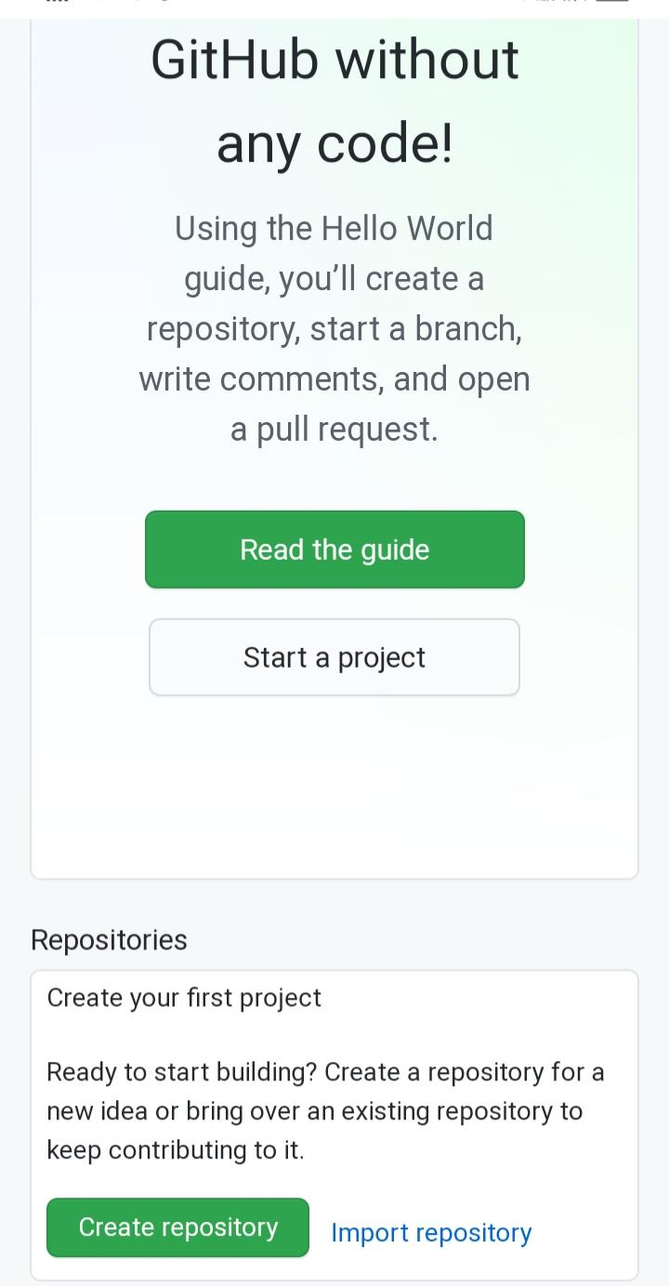

**CLICK HERE TO CREATE NEW REPOSITORY**

**STEP 2 : Enter repository name and description. Also you will have to option PUBLIC (by selecting this option your repository will be visible to everyone) and PRIVATE (by selecting this option your repository will not be visible to others). And you can also add a readme file, gitignore and license. after selecting Option according to your choice click on Create Repository Option.**

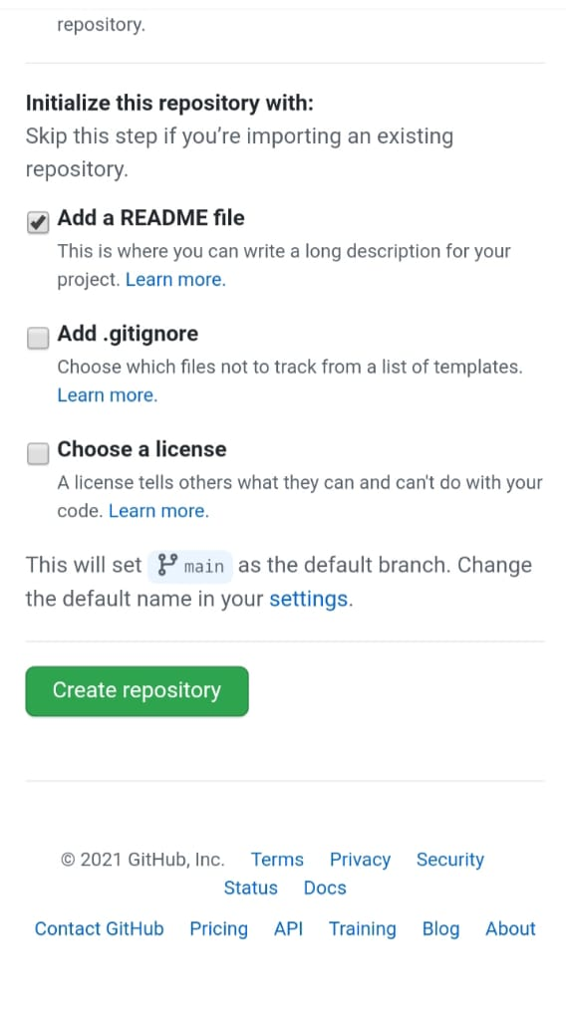**NOW THE NEW REPOSITORY IS CREATED .**

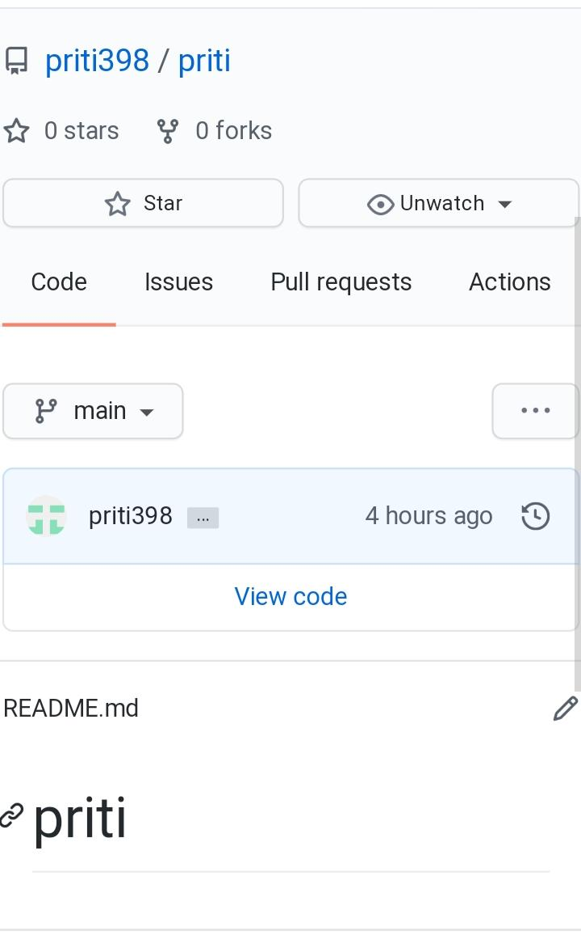**3) Cloning a Repository**

**STEP 1: Click on the CODE option**